Revisions
Rev | Description | Date | Approved
1
2
3

Customer :

SPECIFICATIONS

Model No. : CTT – 1102S Series

◈ INDEX
Approved By | Date | Title | Tactile Switches
Component Engineer |  | 
Acoustic Engineer

Written By |  | Release |  | Sheet No.
- Feature
- Application
- Setting product
- Net weight
- Temperature range
- Standard condition
- Contact arrangement
- Type of actuating
- Rating
- Electrical characteristics
- Mechanical characteristics
- Environmental
- Endurance
- Solder conditions
- Dimensions
- Material list
- RoHS (Result of Analysis)
- REACH SVHC Survey
- Package

1. Features
1-1 Horizontal mounting type and small, low profile design.
1-2 Reflow solderable.

2. Applications
From the operating various of Mobile phones, Digital camcorder, Digital camera and Audio devices for which Low profile and Light weight designs are required.

3. Setting product
CT T - 11 02 S X X

Creative Tact switches Pole&Throw Series No. SMD Terminal Total height Terminal length

4. Net weight : 0.3g / PCS

5. Temperature range
Parameter | Value | Unit
Operating temperature range | -20 ∼ 70 | ℃
Preservative temperature range | -30 ∼ 80 | ℃

6. Standard conditions
Parameter | Value | Unit
Ambient temperature | 5 ∼ 35 | ℃
Relative humidity | 45 ∼ 85 | % Rh
Air pressure | 860 ∼ 1060 | mBar
If doubt arises on the design based on the measured values under the above mentioned conditions, the following conditions shall be employed.
Parameter | Value | Unit
Ambient temperature | 18 ∼ 22 | ℃
Relative humidity | 60 ∼ 70 | % Rh
Air pressure | 860 ∼ 1060 | mBar

7. Contact arrangement : SPST

8. Type of actuating : Tactile feedback
9. Rating
Maximum rating | 12 V (DC) , 50 mA
Minimum rating | 2 V (DC) , 10μA

10. Electrical characteristics
No | Item | Test conditions | Evaluation
1 | Contact resistance | 1-1 Push force : Operating force X 2  1-2 Small current contact resistance meter  : 1Khz , 20mV , 5∼50mA | 100mΩ MAX.
2 | Insulation resistance | 100V (DC) / 1 Minute (Between terminal) | 100MΩ MIN.
3 | Dielectric withstand voltage | AC 250V (50Hz OR 60Hz) / 1 Minute  (Between terminal) | No break down
4 | Bouncing | 3 to 4 Operations per second  (Switch bouncing circuit) | On / Off :  10ms MAX.

11. Mechanical characteristics
No | Item | Test conditions | Evaluation
1 | Operating force | Push by recommended operating conditions | Push force :  As per assembly drawing  Return force :  As per assembly drawing
2 | Travel | Operating force x 2 | 0.25±0.1mm
3 | Stem strength | 1Kgf for 5 sec. | No damage  (Electrical and Mechanical)
4 | Soldering heat test | Mounted the switch on P.W.B by adhesive.  1) Reflow process one time.  2) Standard conditions after test  : 24 Hours | No damage  (Electrical and Mechanical)

12. Environmental
No | Item | Test conditions | Evaluation
1 | Storage heat | 1) +80±2℃ , 96 Hours  2) Standard conditions after test 1 Hour. | After the test the part shall satisfy. Specifications without any degradation in appearance and performance.
2 | Storage cold | 1) -30±2℃ , 96 Hours  2) Standard conditions after test 1 Hour.
3 | Humidity | 1) 40 ±2℃ , 90∼95% Rh , 96 Hours  2) Standard conditions after test 1 Hour.
4 | Temperature cycle | 1) Test cycles : 5 Cycles  2) Standard conditions after test 1 Hour.

13. Endurance
No | Item | Test conditions | Evaluation
1 | Operating life | 1) 5V (DC) , 50mA  2) 140 Operations/min , Maximum value of  operation force.  3) As per assembly drawing | After the test the part shall satisfy. Specifications without any degradation in appearance and performance.
Notes
As this product is not protected from foreign material entering please make sure that any foreign material (E.G Magnetic powder, Washing solvent, Flux, Corrosive gas) Do not enter this product in your production process.

14. Solder conditions

14-1 SMD Reflow

Parts | Temperature (℃) | Time at temperature(sec) | Treatments
A | NO - 150
B | 150 - 180 | 90 ±30 | Pre-heating zone
C | 180 - 230
D | 230 – 255 - 230 | 30 ±10 (Peak : 3 MAX.) | Soldering zone
E | 230 to NO |  | Cooling zone

** NO : Normal conditions

14-2 Solder cream thickness
0.12 ±0.03

14-3 Manual soldering

14-3-1 Iron tip temperature : 350 ±5℃ MAX.
14-3-2 Duration : 3sec MAX.

15. Dimensions
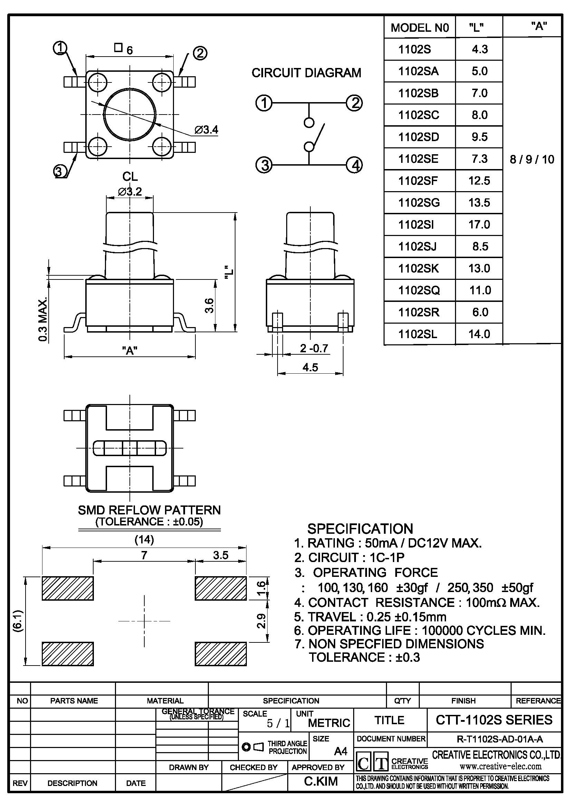
16. Material list
No. | Parts name | Material | Specification | Reference
1 | Stem | Polyamide
2 | Cover | Stainless | STS 300
3 | Contact | Ag-Phosphor bronze | Ag – C5210R | Ag Plate
4 | Case | Polyamide
5 | Terminal | Brass | C2680R | Ag Plate

17. RoHS (Result of Analysis)
No. | Parts name | Material | Result of Analysis（PPM） |  |  |  |  |  | Test report NO.
No. | Parts name | Material | Cd | Pb | Cr⁶⁺ | Hg | PBB | PBDE | Test report NO.
1 | Stem | Polyamide | N/D |  |  |  |  |  | F690501/LF-CTSAYAA17-35718 (SGS)
2 | Contact | Ag-Phosphor bronze | N/D | 22.8 | ND |  |  |  | F F690501/LF-TSAYAA17  13669 (SGS)
3 | Terminal | Brass | N/D | 26 | N/EGATIVE | ND |  |  | F690501/LF-TSAYGU16  09748 (SGS)
4 | Cover | Stainless | N/D |  |  |  |  |  | F690501/LF-CTSAYGU17-02457 (SGS)
5 | Case | Polyamide | N/D |  |  |  |  |  | F690501/LF-CTSAYAA17-35718 (SGS)
18. REACH SVHC Survey
18-1 Survey
NO | Manufacturer PN | Description | SVHC Substance Name | Substance CAS no. | Substance Weight (grams) | Substance Weight % (relative to the whole product) | Substance Where Used | Anticipated Phase out date (mm/dd/yyyy)
1 | P-T1102S-ST-01A | Stem | N / A
2 | P-T1102S-TE-01A | Terminal
3 | P-T1102S-CA-01A | Case
4 | P-T1102S-CN-01A | Contact
5 | P-T1102S-CO-01A | Cover

18-2 List of SVHC
Substance | CAS No. | Contained in EEE products | Used only in manufacturing of EEE products
Anthrancene | 120-12-7 | Radiation equipment | Yes, but rarely used
4,4’-Diaminodiphenylmethane | 101-77-9 | No | Intermediate for some epoxy resin, specialty polymers and PU foam
Cyclododecane | 294-62-2 | No | Used in the production of polyamides, polyesters and nylon. Also found as Intermediate for HBCDD.
Cobalt dichloride | 7546-79-9 | No | Used in cobalt plating
Diarsenic pentaoxide | 1303-28-2 | No | Hardener for copper, lead and gold alloys
Diarsenic trioxide | 1327-53-3 | No | Usage in GaAs alloys
Sodium dichromate | 7789-12-0 | No | Passivation coating/plating and paint primer
5-tert-butyl-2,4,6-trinitro-m-xylene (musk xylene) | 81-15-2 | No | No
Dibutyl Phthalate (DBP) | 84-74-8 | Plasticizer in plastics, varnishes and paper coatings. Also used as additive to inks, resins and adhesives | No
Bis (2-ethyl(hexyl)phthalate) (DEHP) | 117-81-7 | Plasticizer in PVC cables, wire jacketing, inks and adhesives | No
Benzyl butyl phthalate (BBP) | 85-68-7 | Plasticizer in PVC cables, wire jacketing, inks and adhesives | No
Hexabromocyclododecane (HBCDD) | 25637-99-4 | Flame retardant in plastics and foam. | No
Alkanes, C10-13, chloro (Short Chain Chlorinated Paraffins) (SCCPs) | Various | Rarely found, but can be used as a flame retardant and plasticizers. | Cutting fluids
Bis(tributyltin) oxide (TBTO) | 56-35-9 | Rarely used. Mainly used for antiseptic, antifungal agent. | No
Lead hydrogen arsenate | 7784-40-9 | Wood treatment | No
Triethyl arsenate | 15606-95-8 | Wood treatment | No
19. Package
  - Package Q’TY
- CTT-1102W/S : 1,000 PCS
- CTT-1102SB : 700 PCS
- CTT-1102SC : 600 PCS
- CTT-1102SD : 500 PCS
- CTT-1102SF : 250 PCS

